Project Management Tool

1.Create a project Net Banking Application
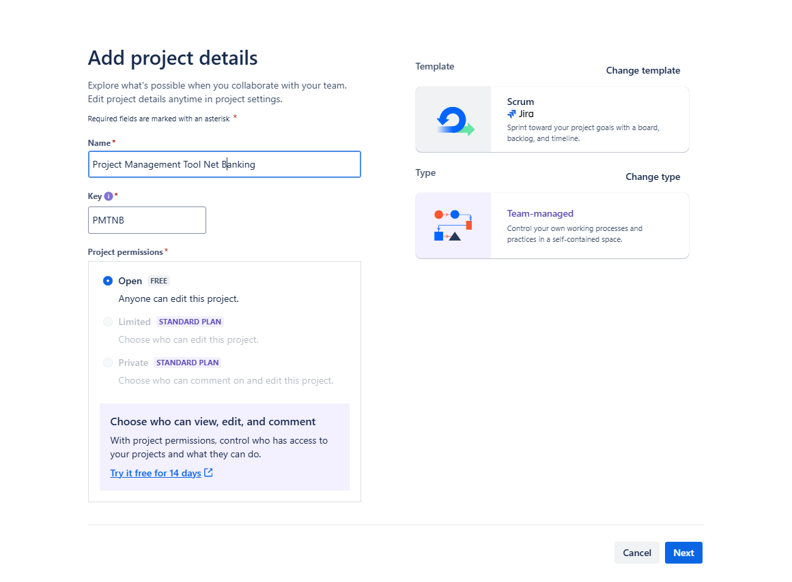
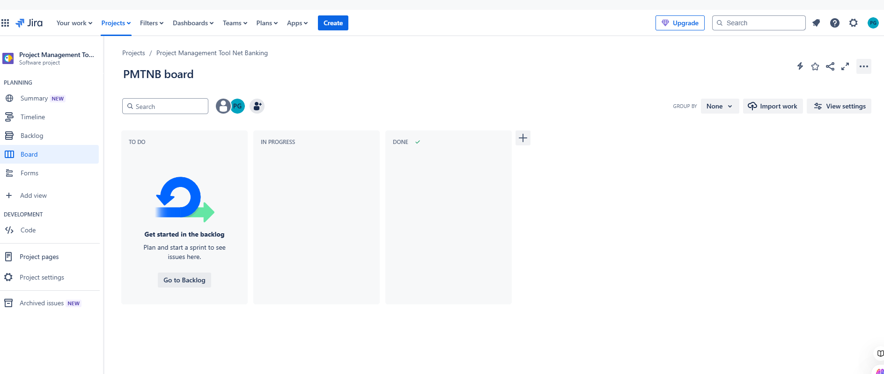

2.Create 5 Epic
- Login Module
- Payment module
- Transaction module
- Security module
- Customer Relationship Module

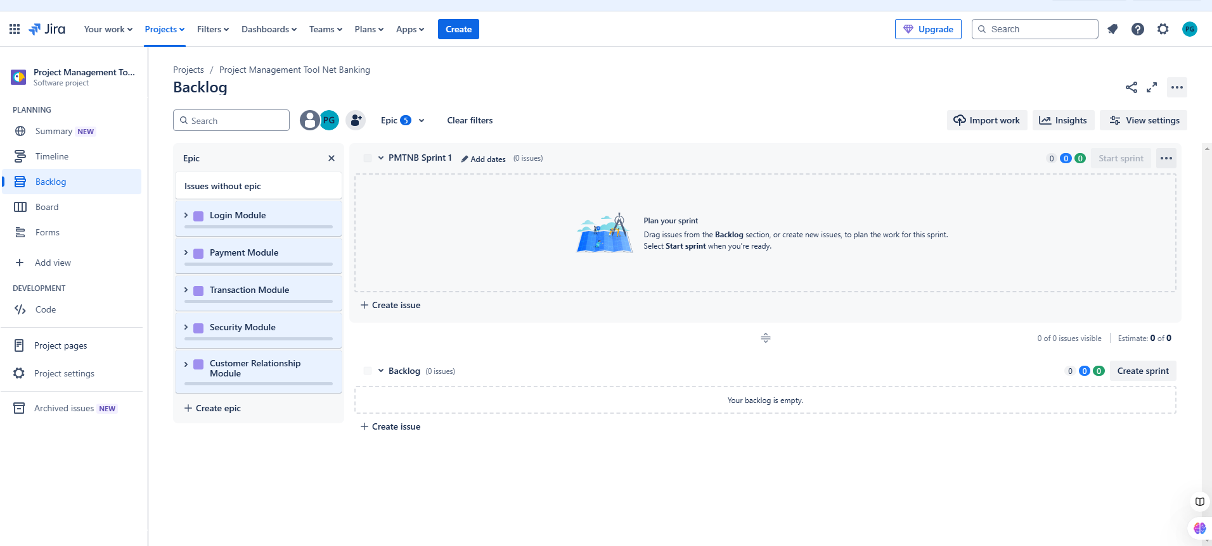
3.Create 2 User Story for each Epic in Product Backlog
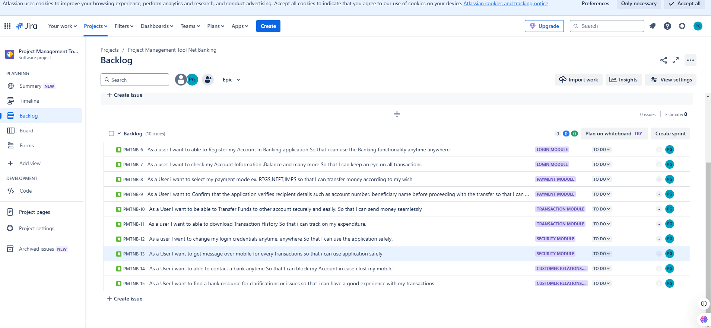

4.User Story Description
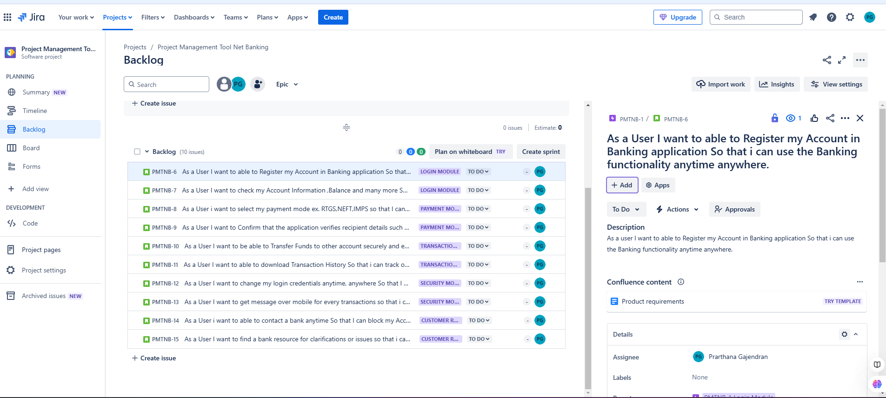
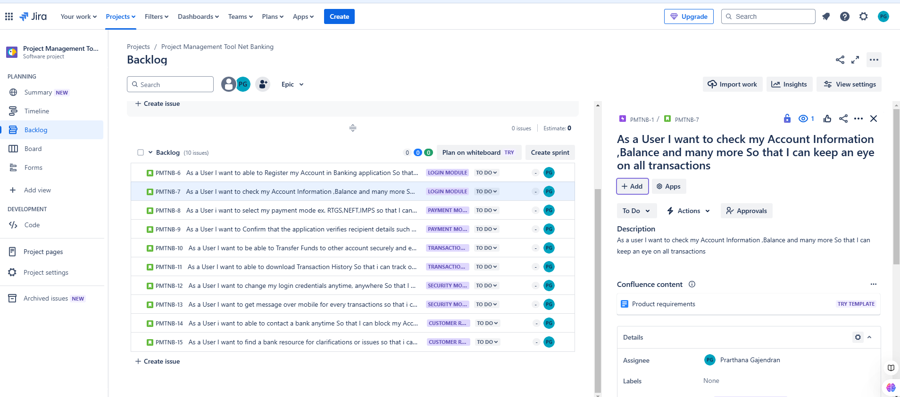
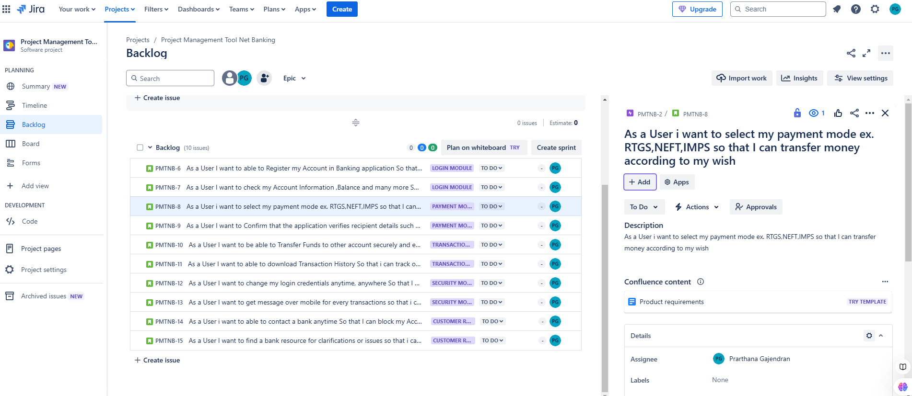
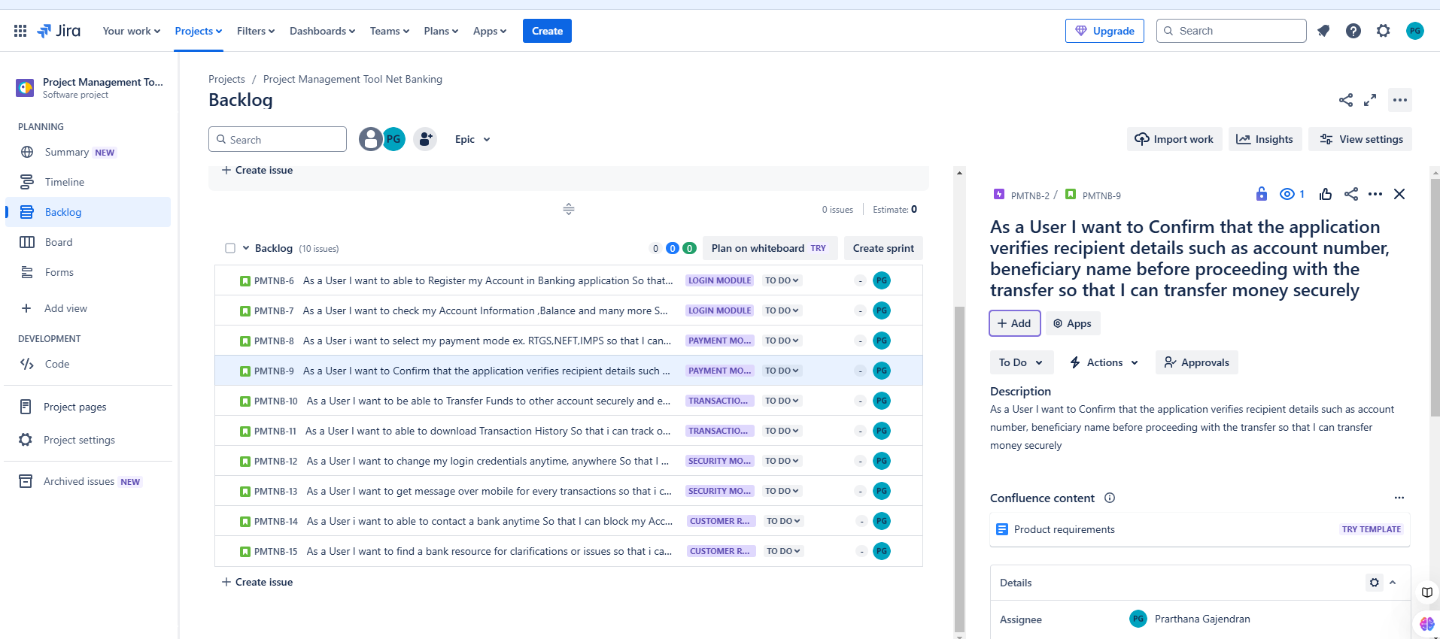
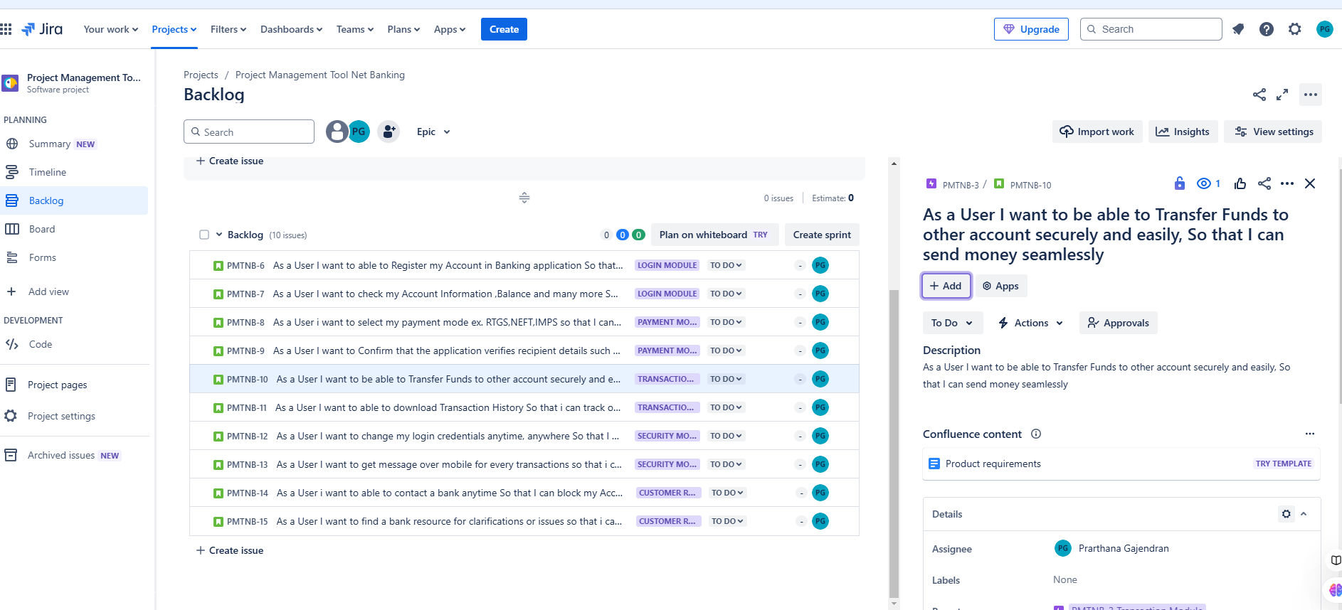
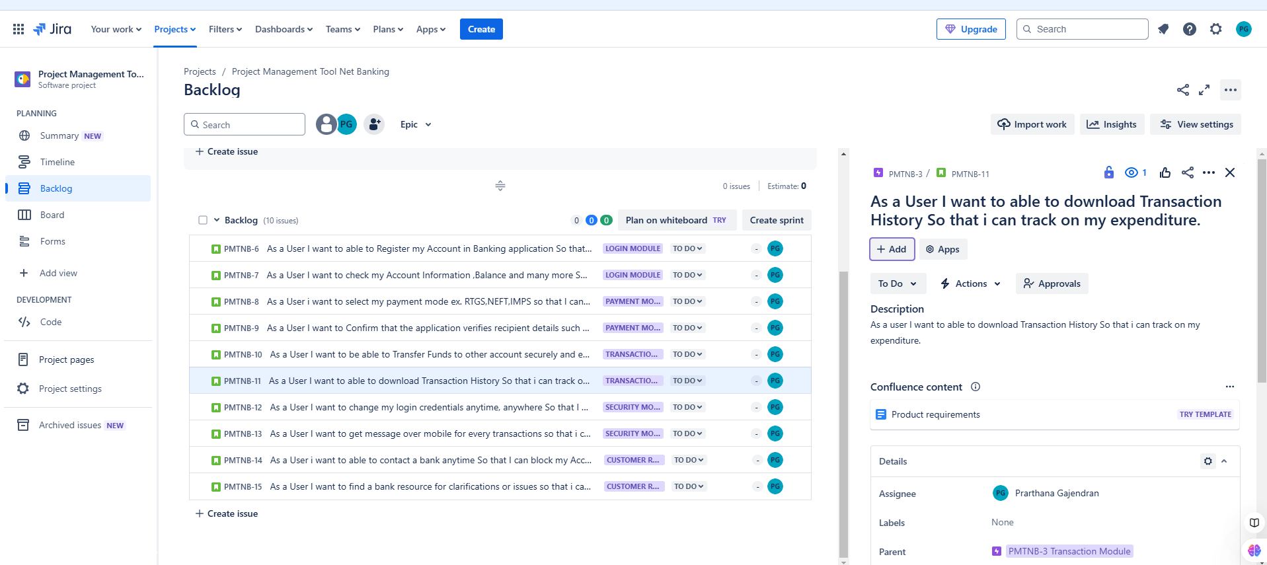
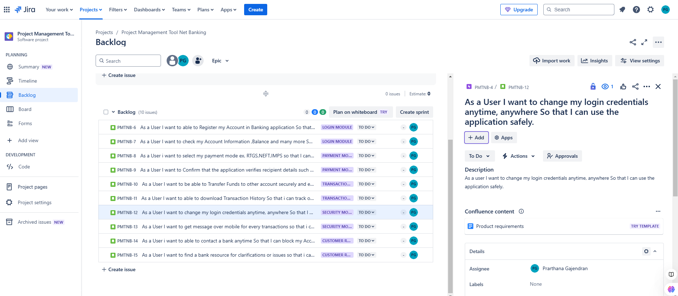
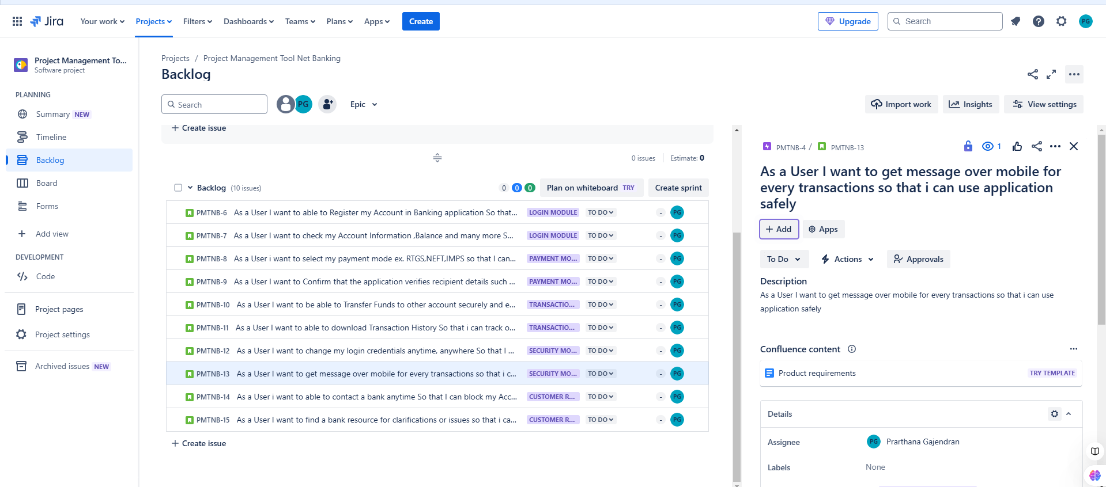

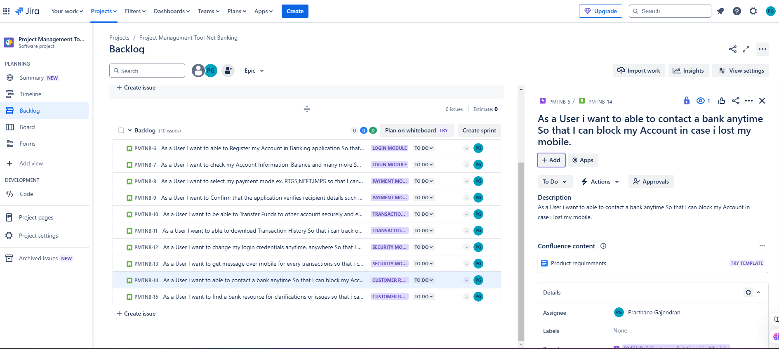
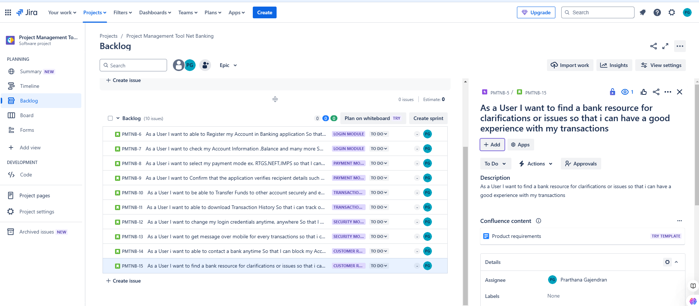
8.Based on the complexity 5 sprint created

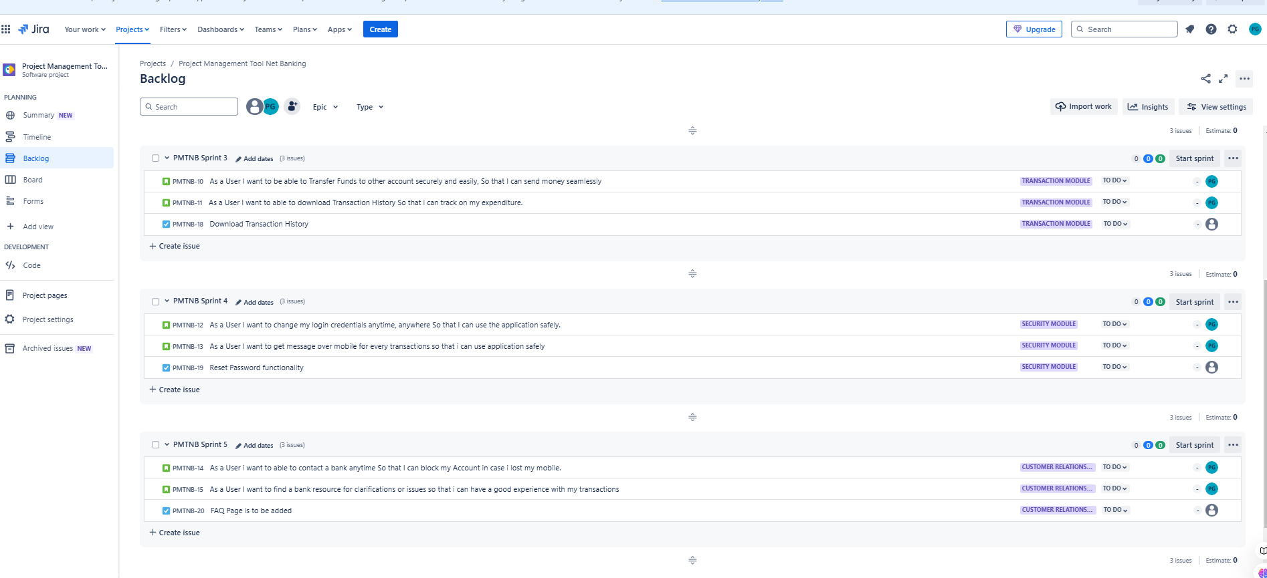

5.Sprint 1 created for Login Module

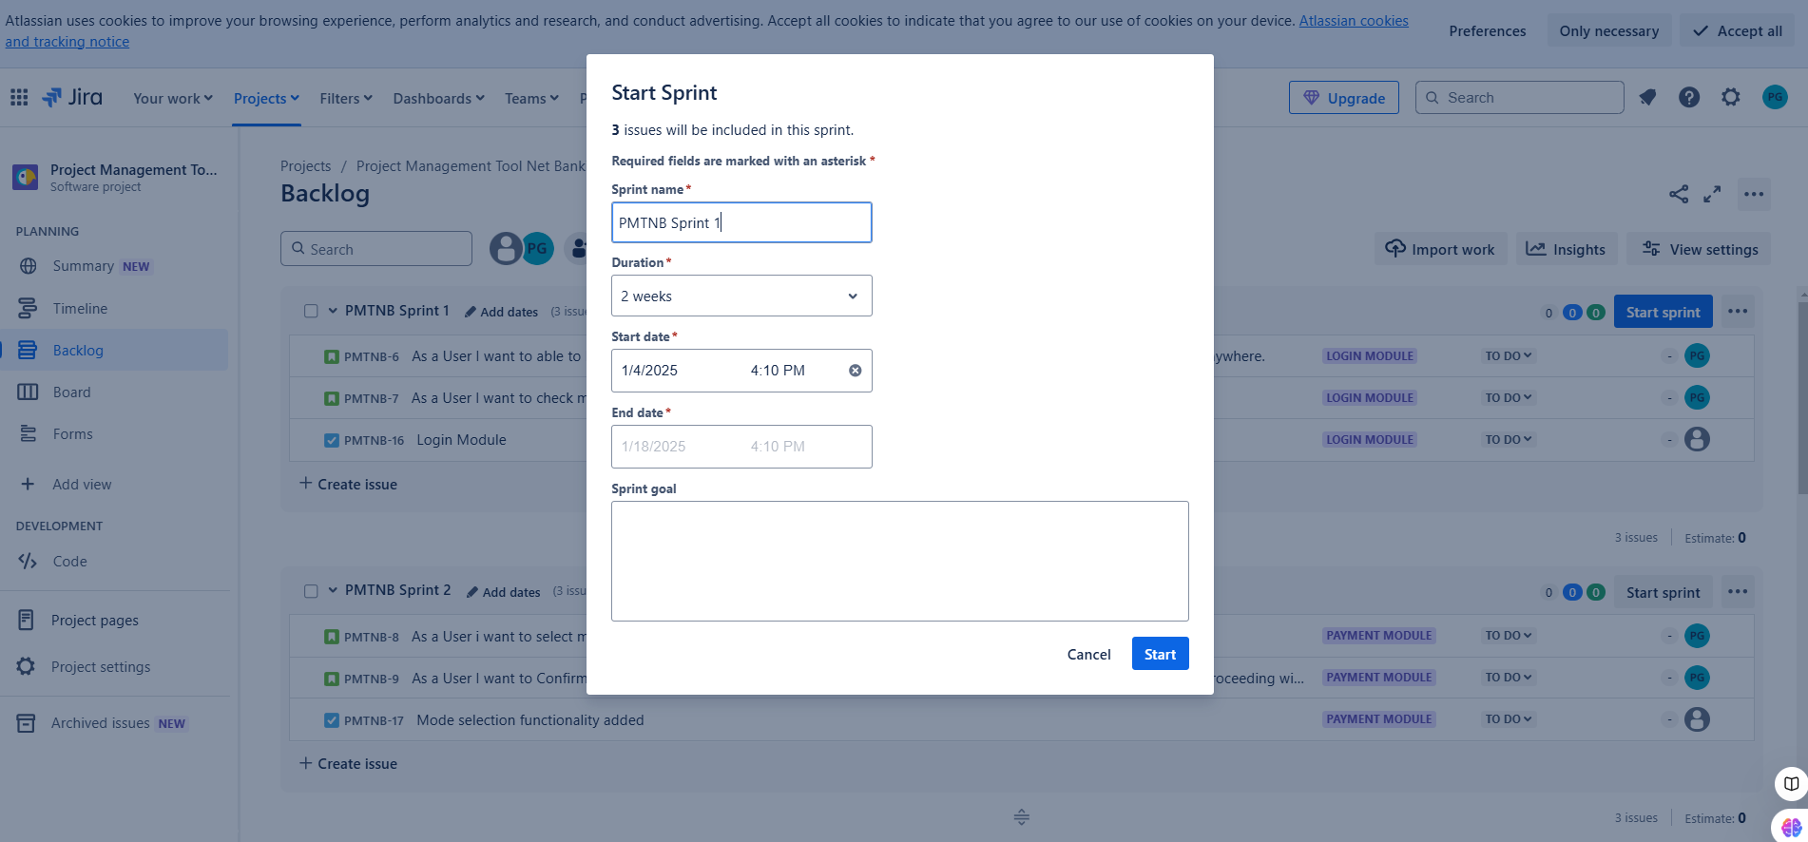

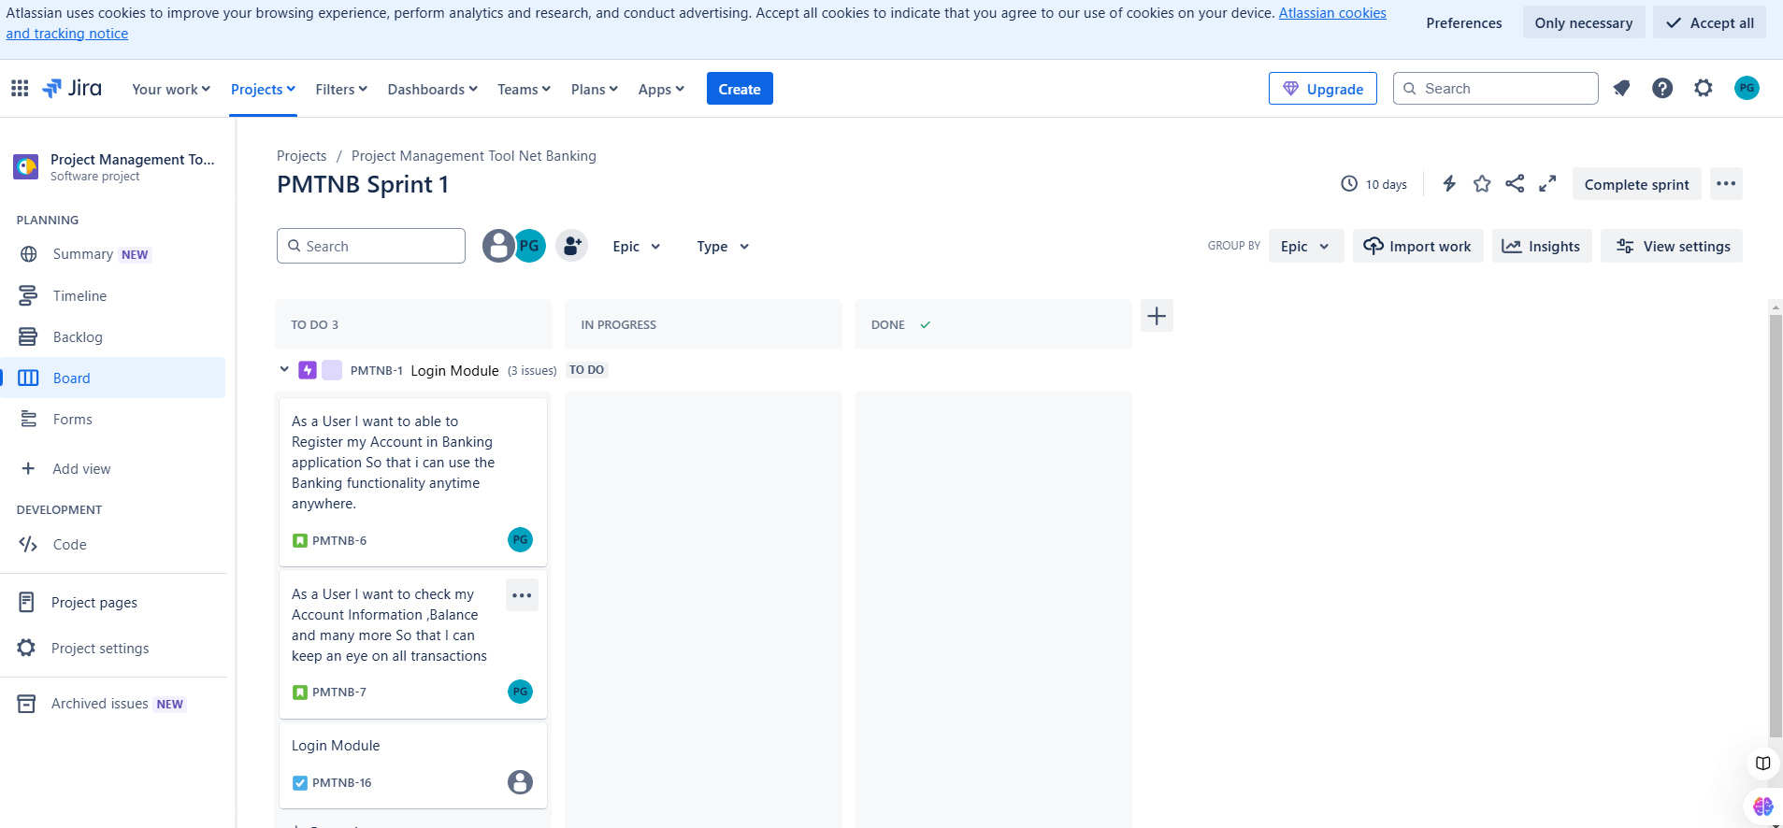

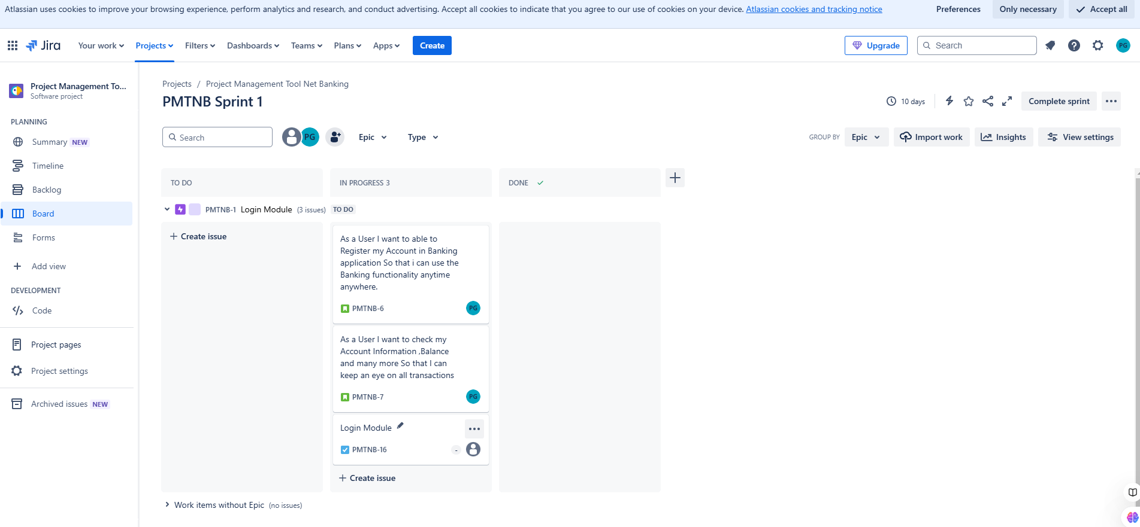
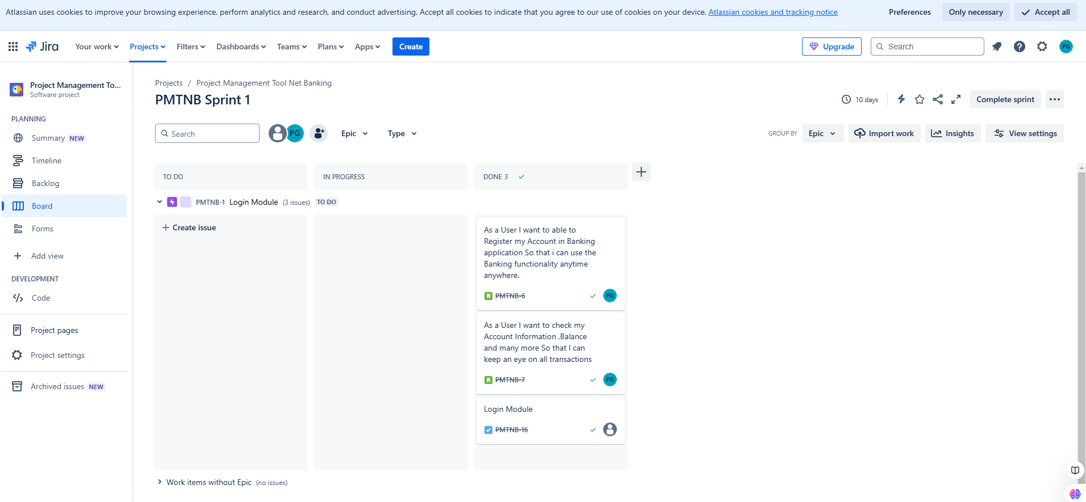

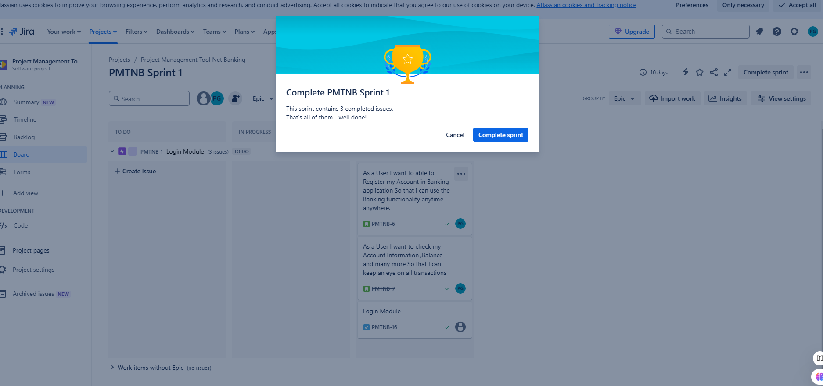

6.Sprint 2 created for Payment module

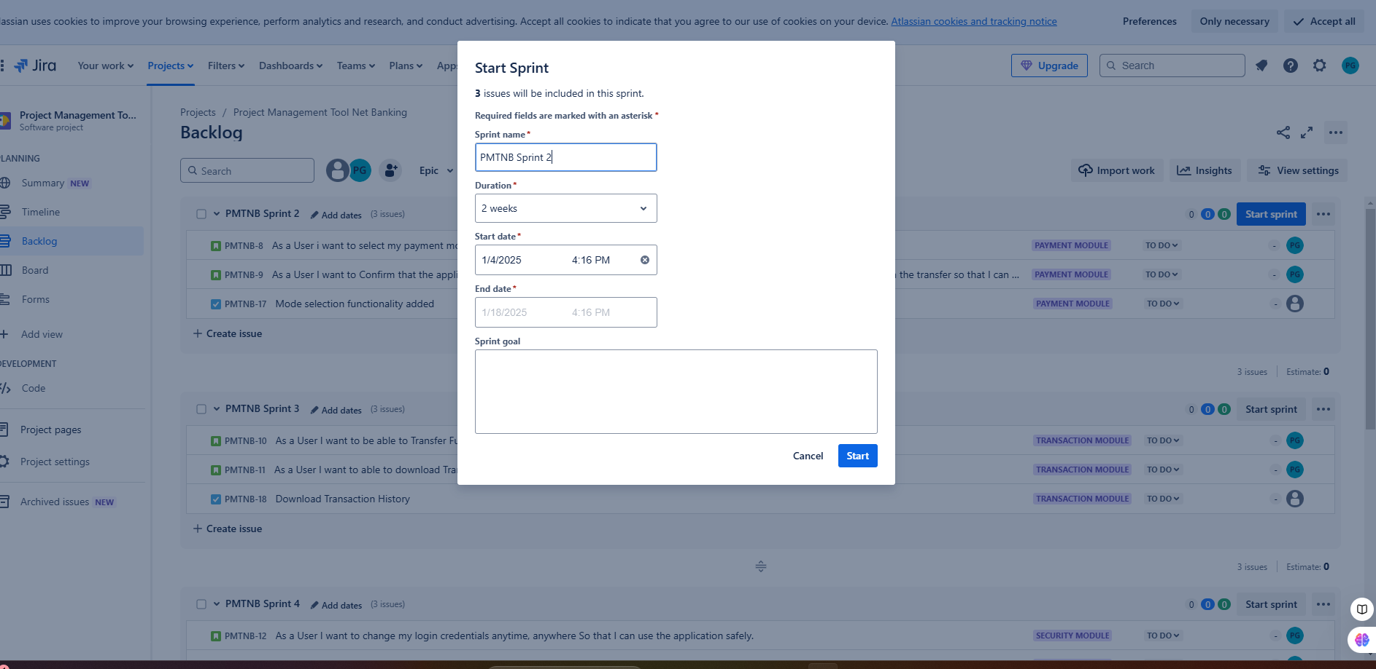

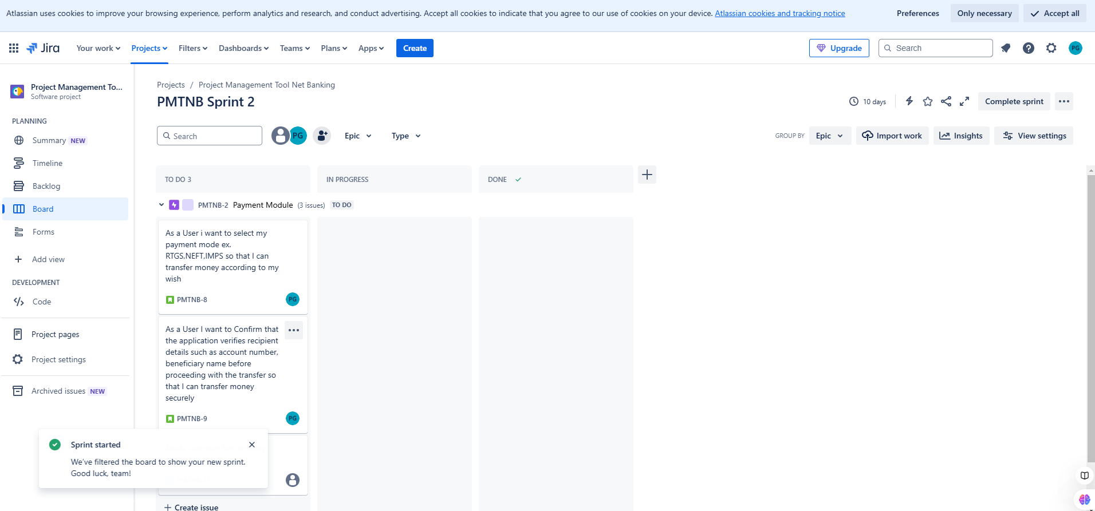

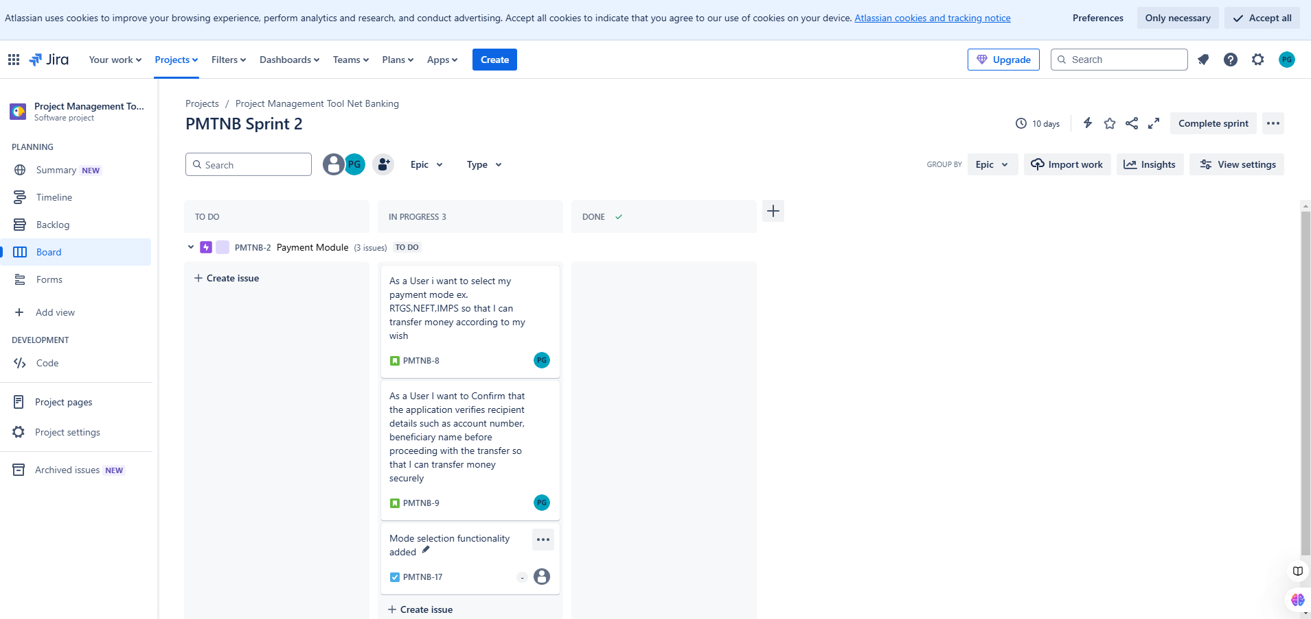

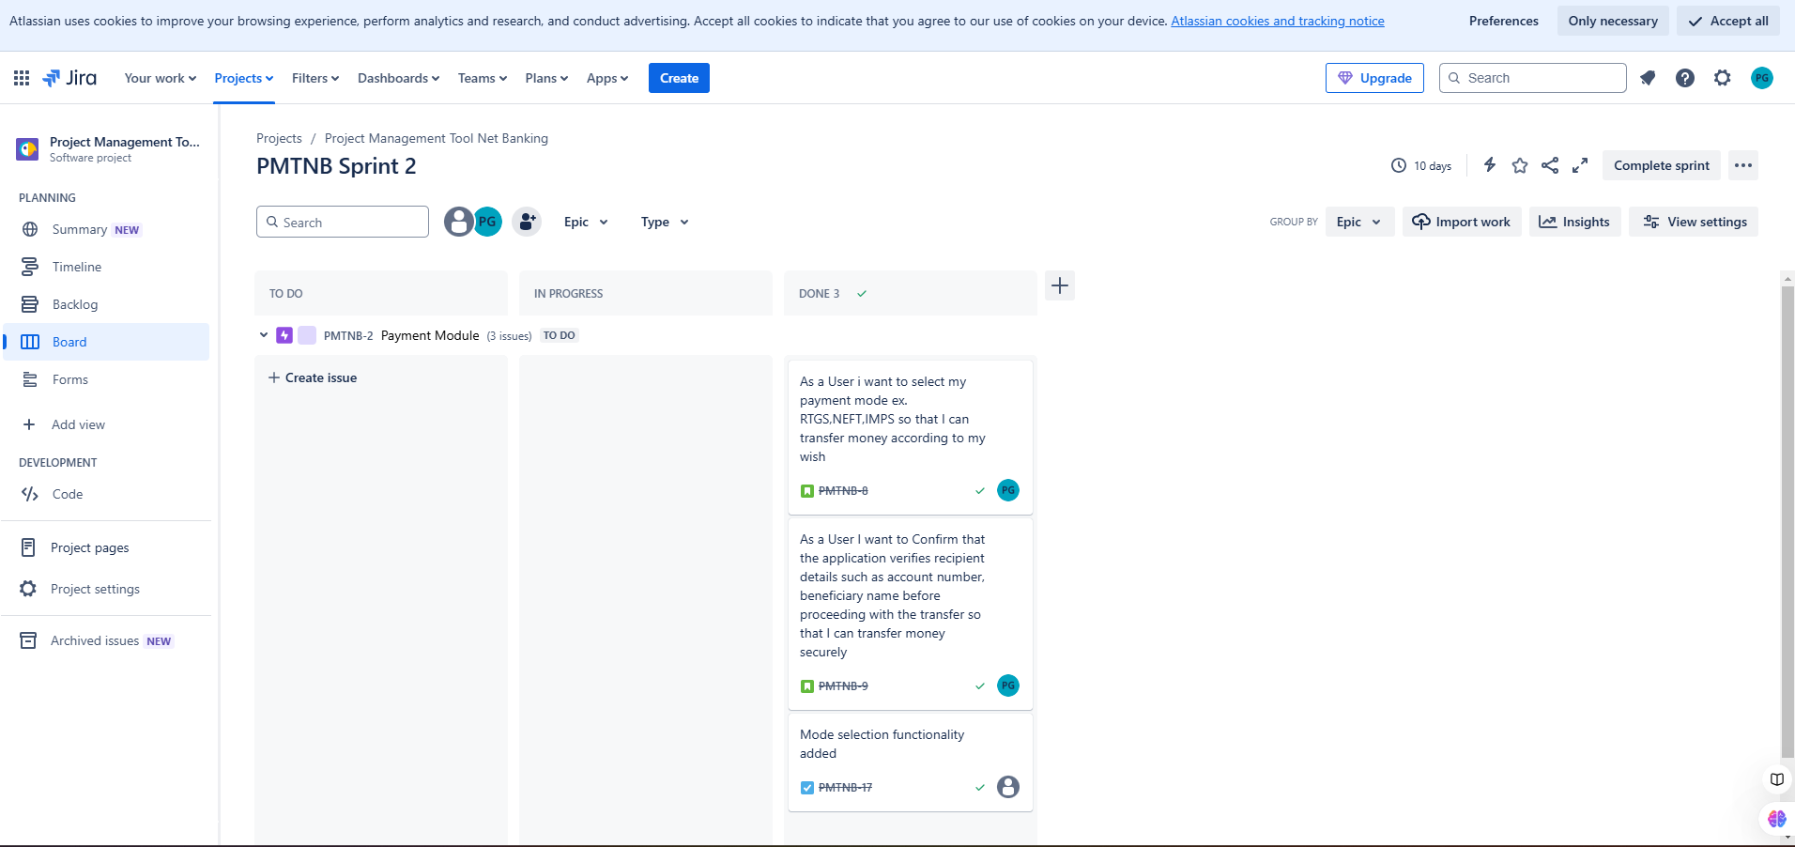

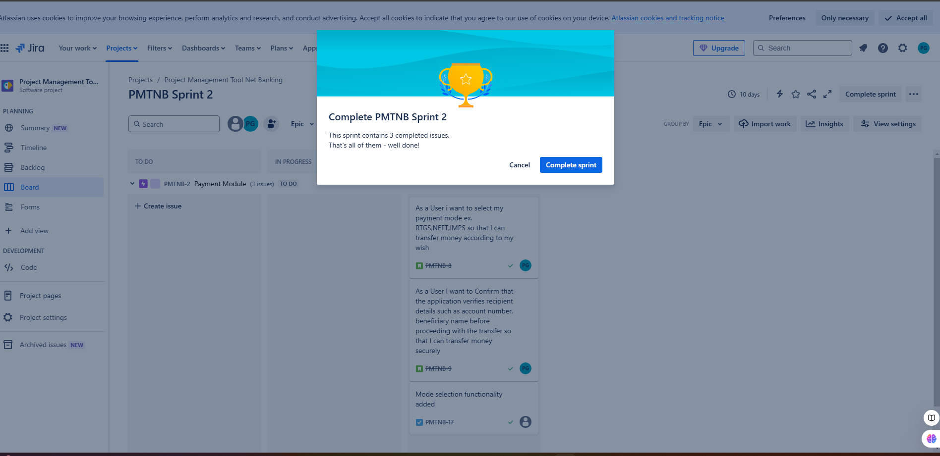

7.Sprint 3 created for Transaction Module
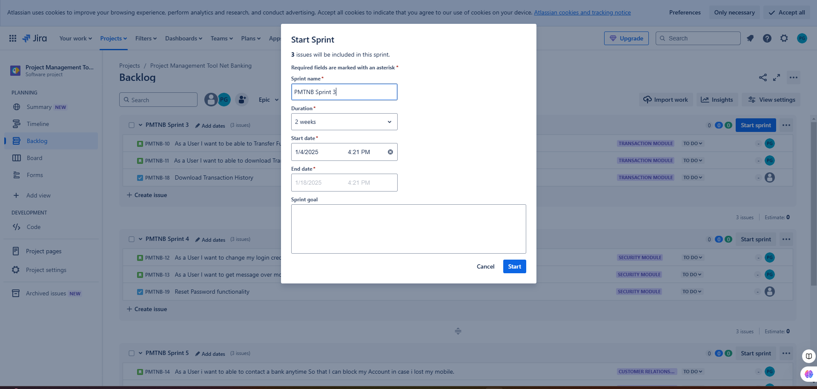

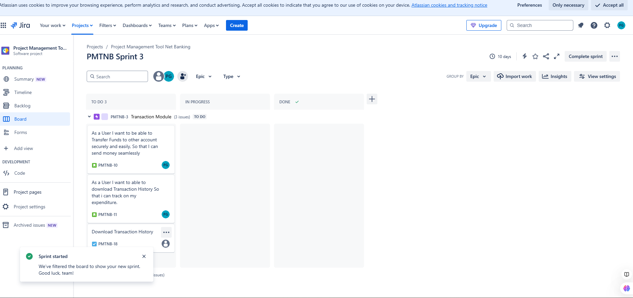

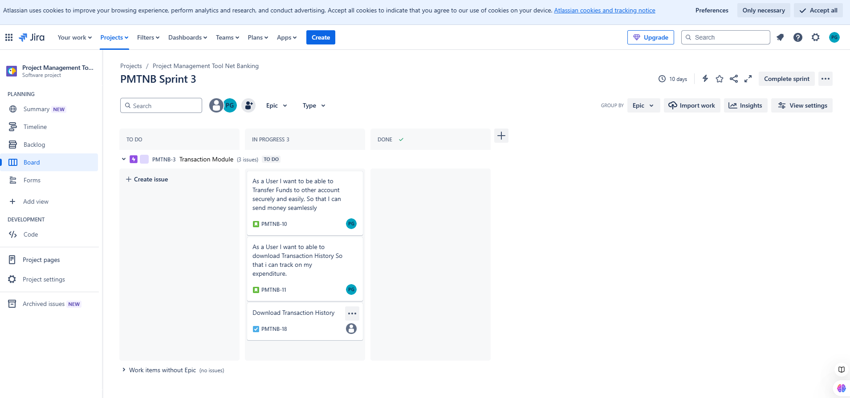

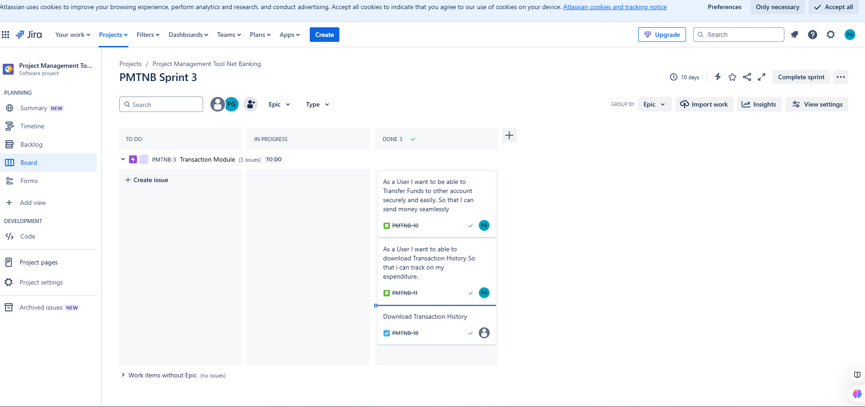

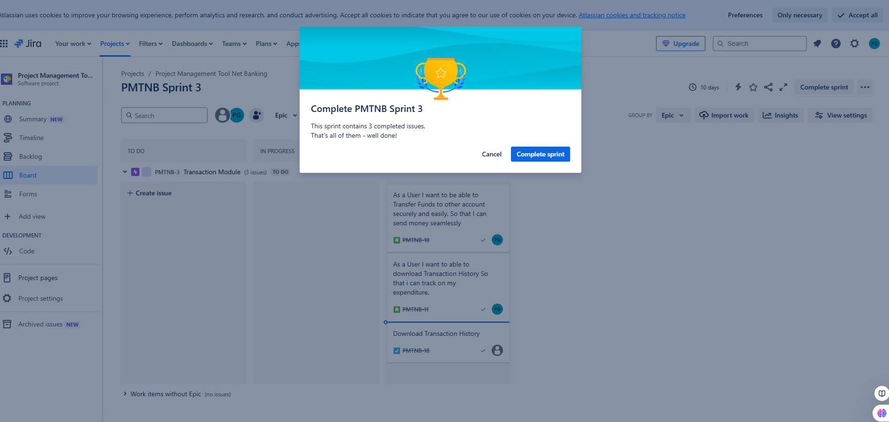
8.Sprint 4 created for Security Module
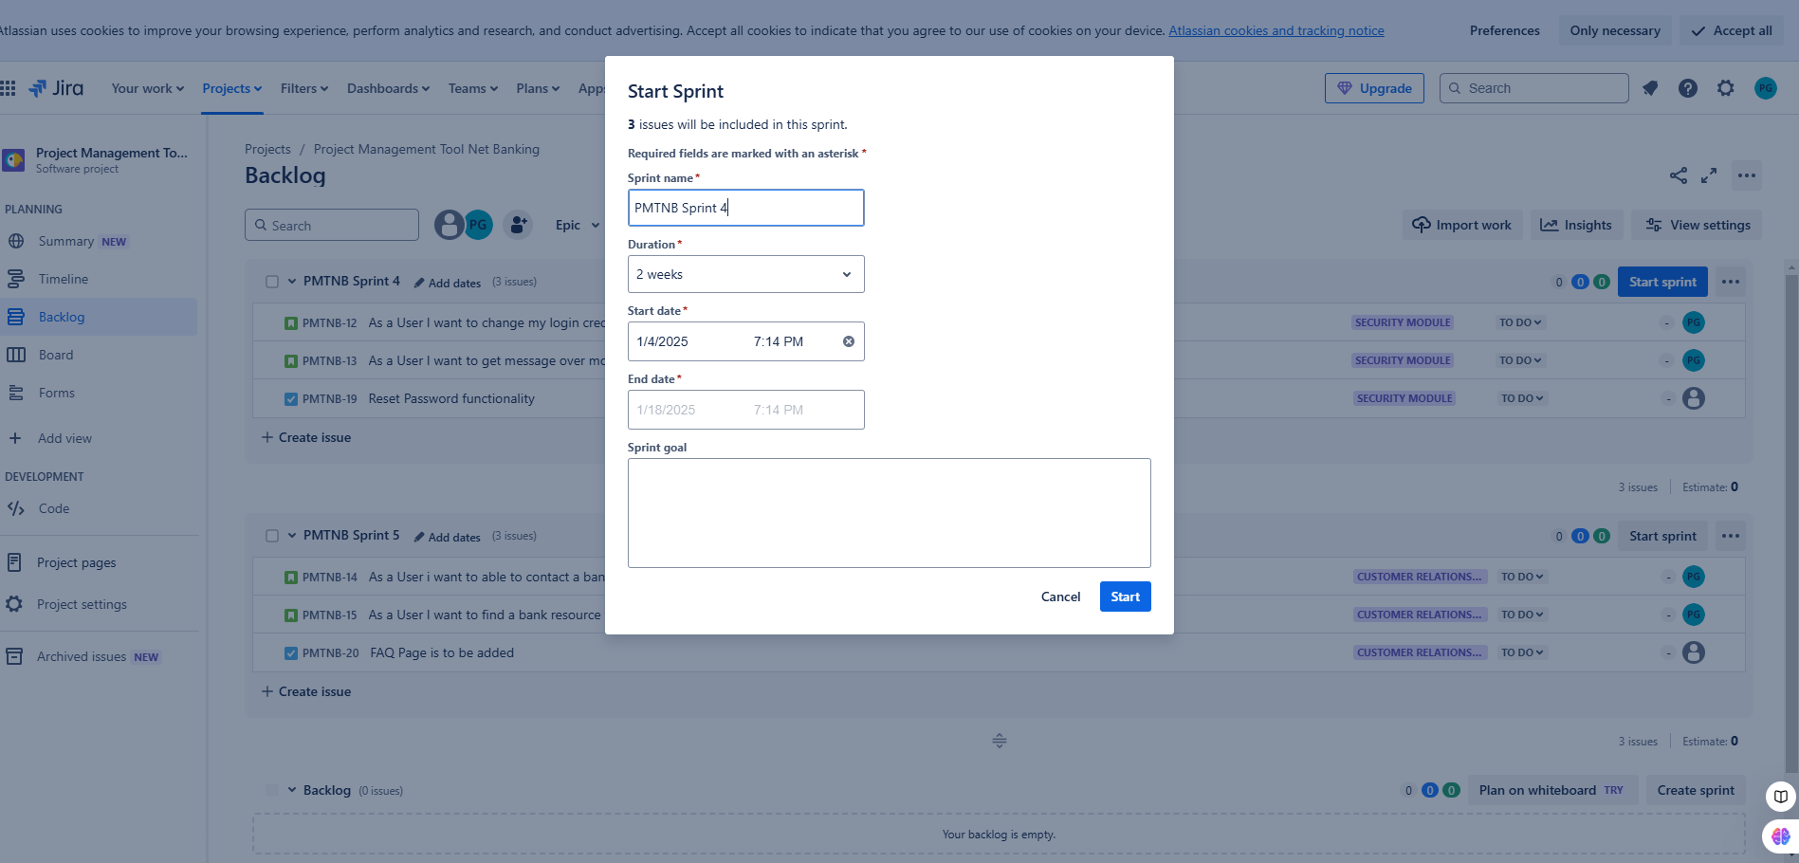

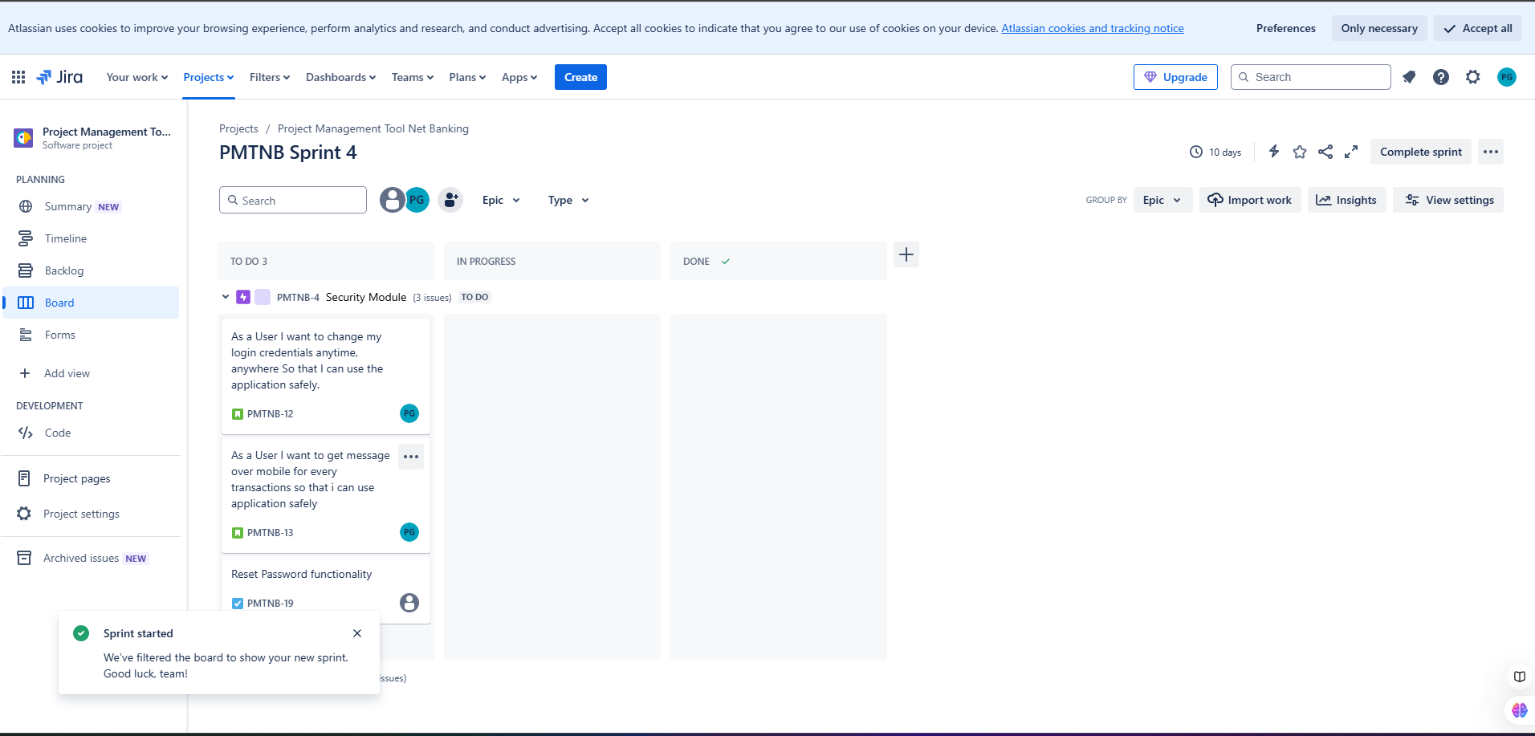

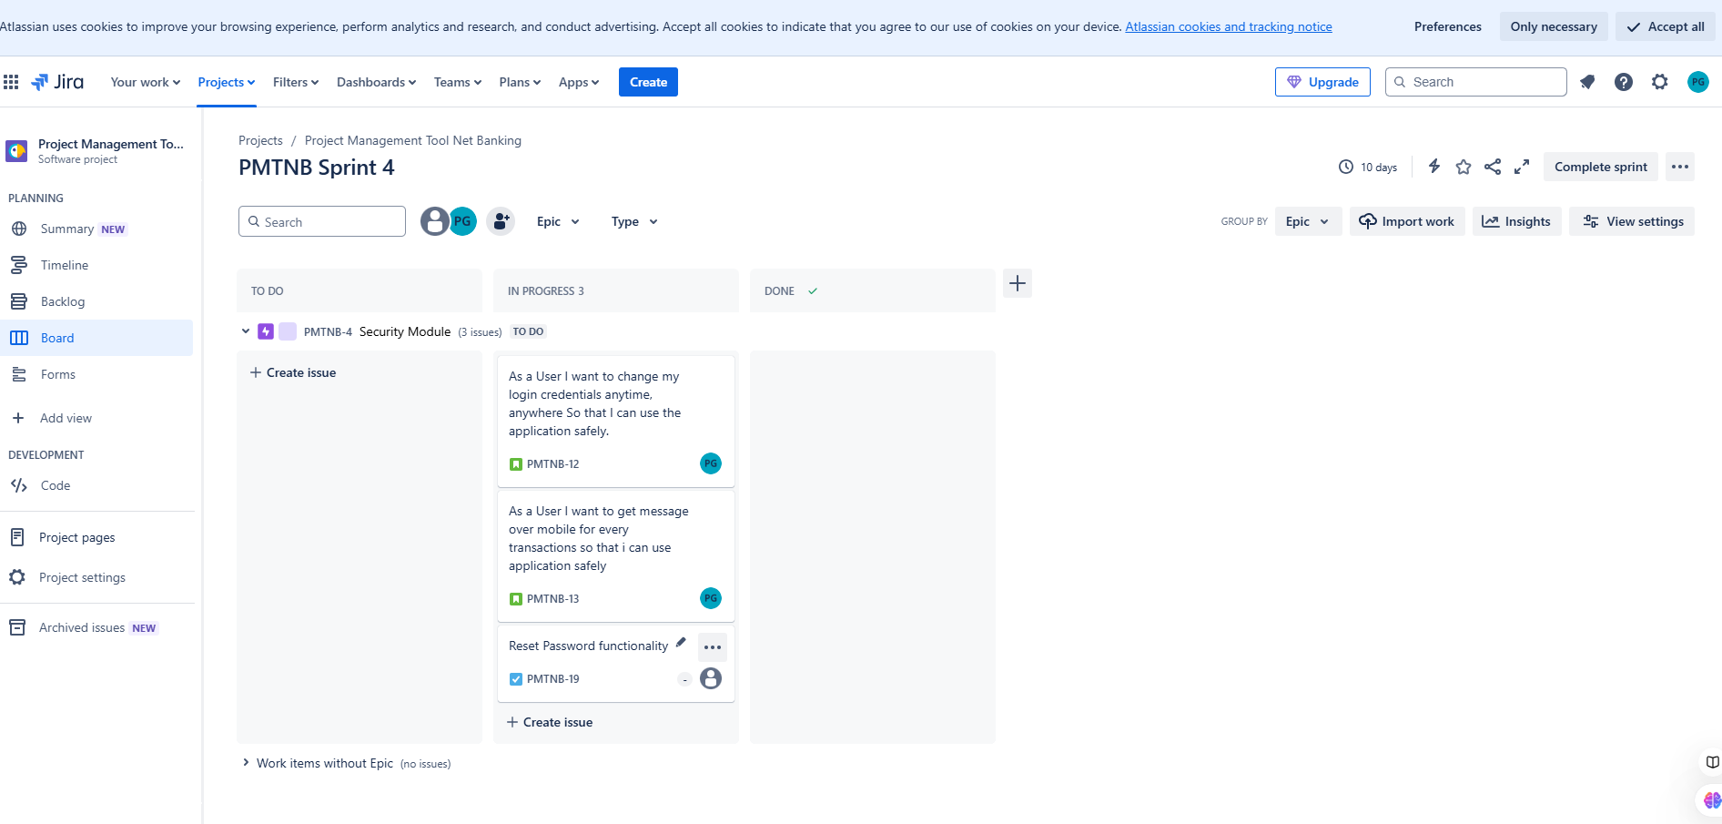

9.Issue created in Security module
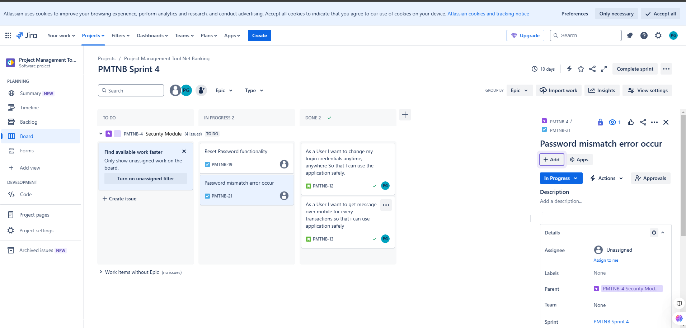
10.Issue cleared in same sprint
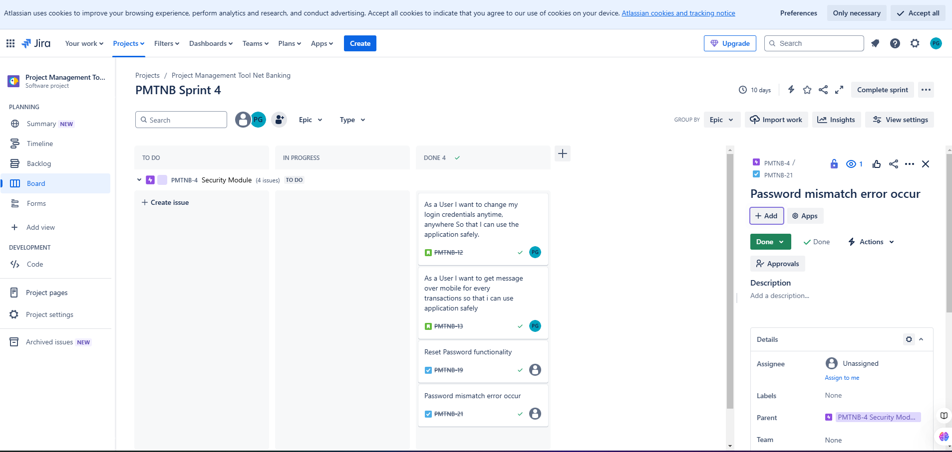

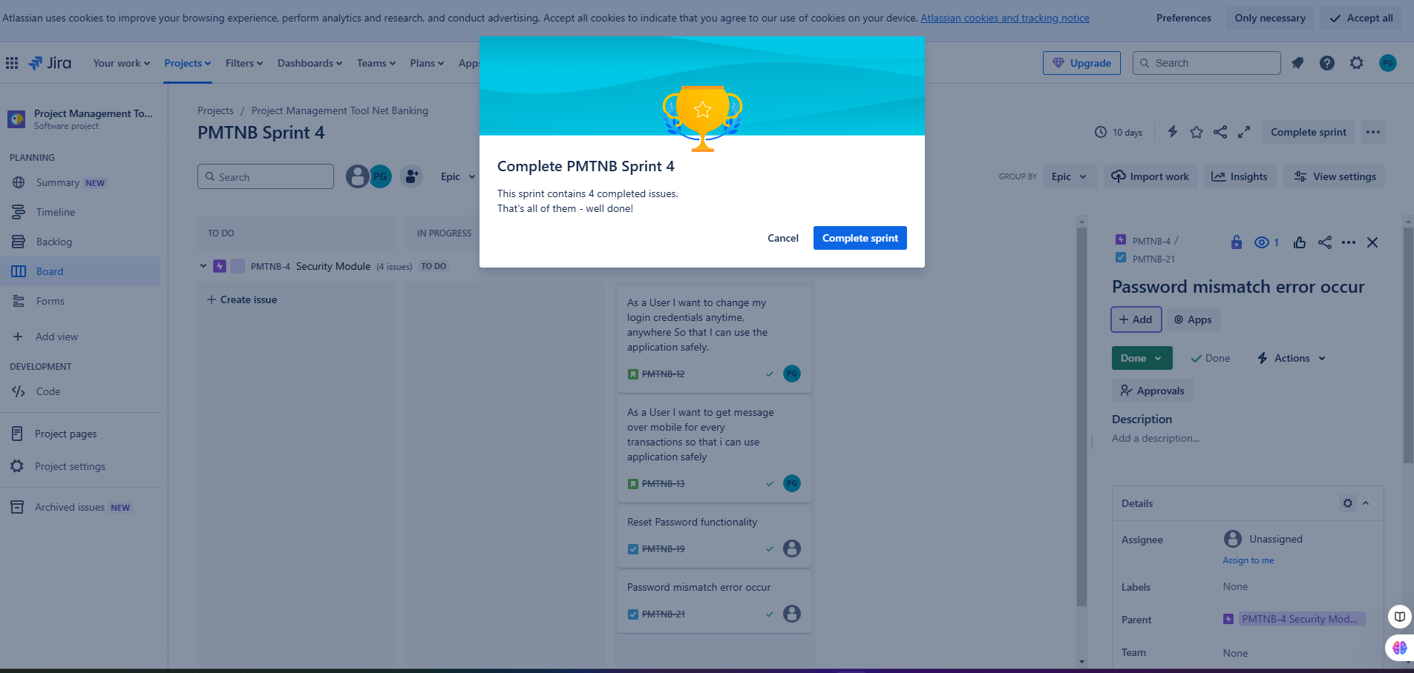
11.Sprint 5 created for Transaction Module
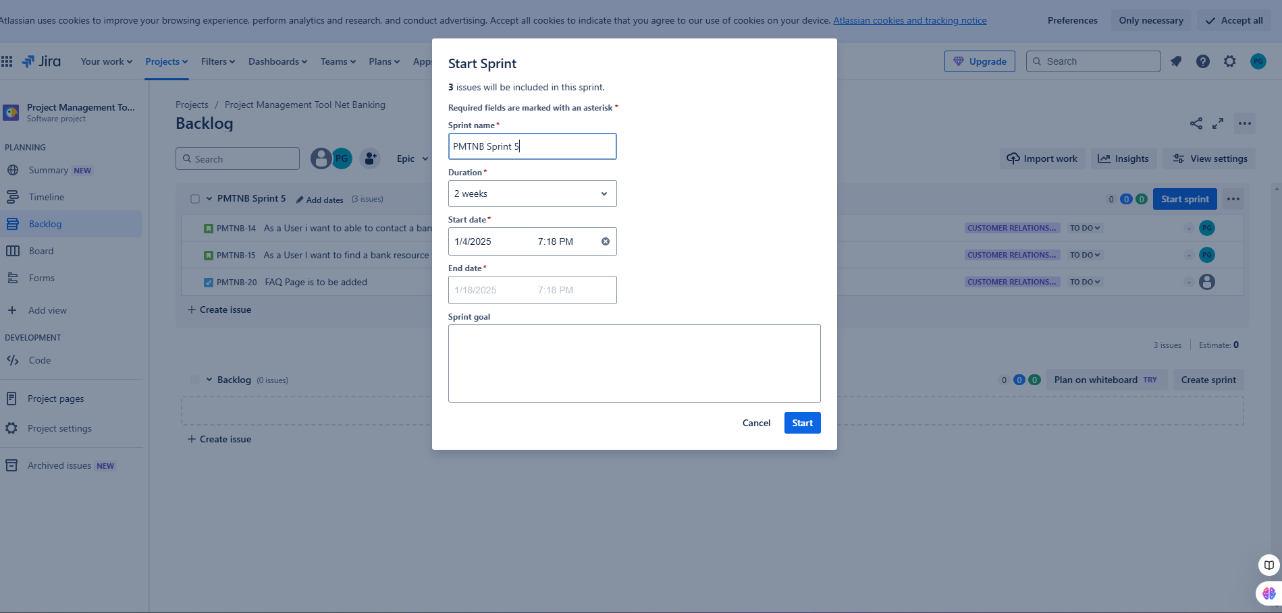

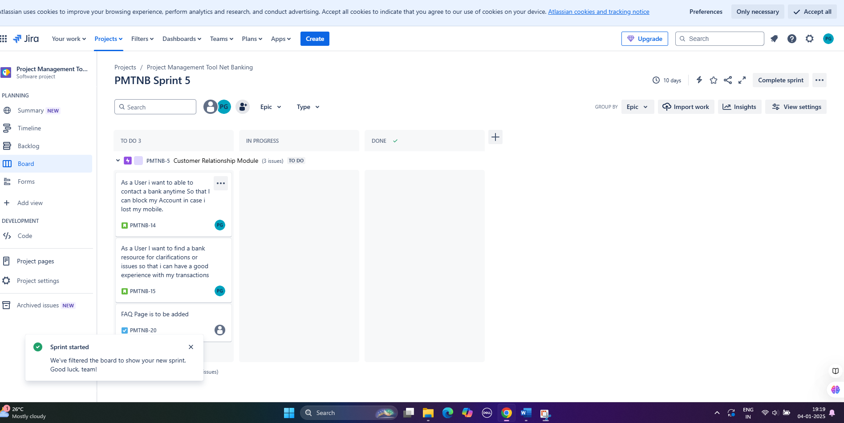

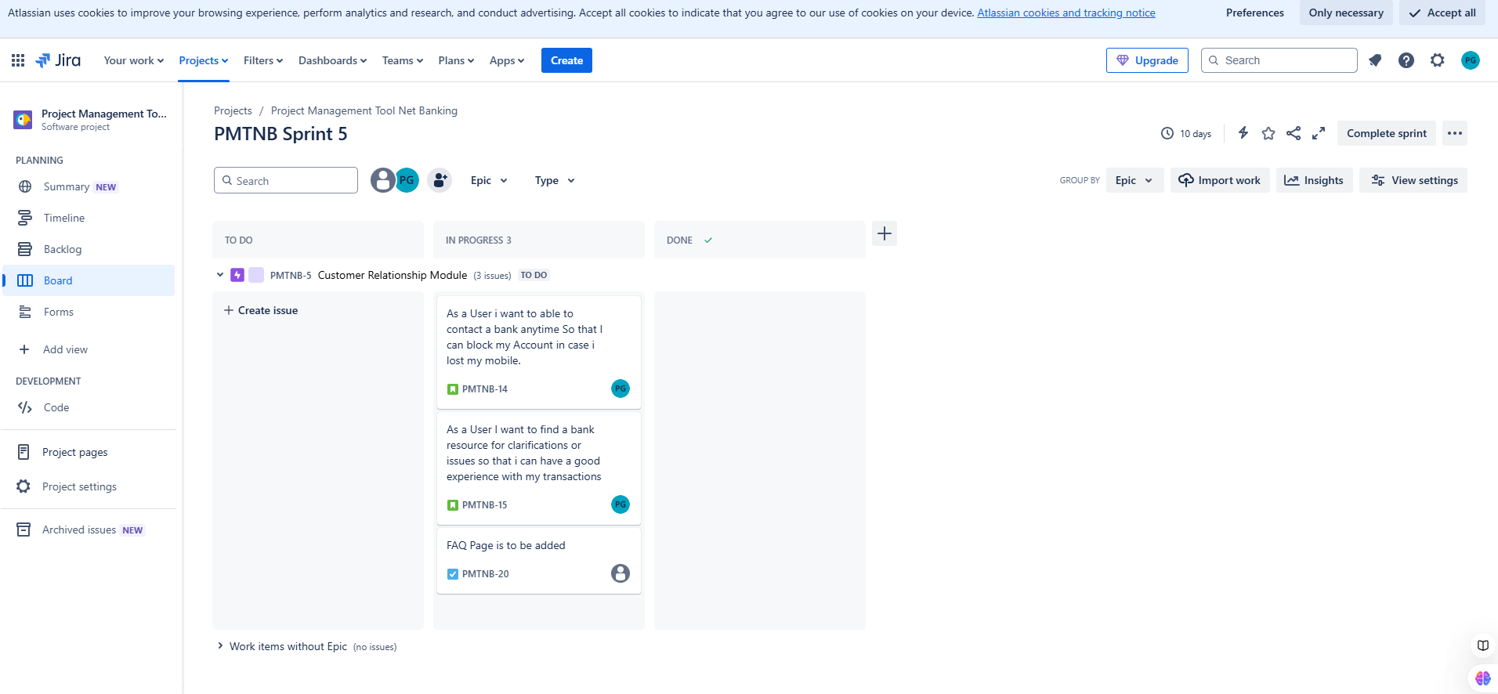

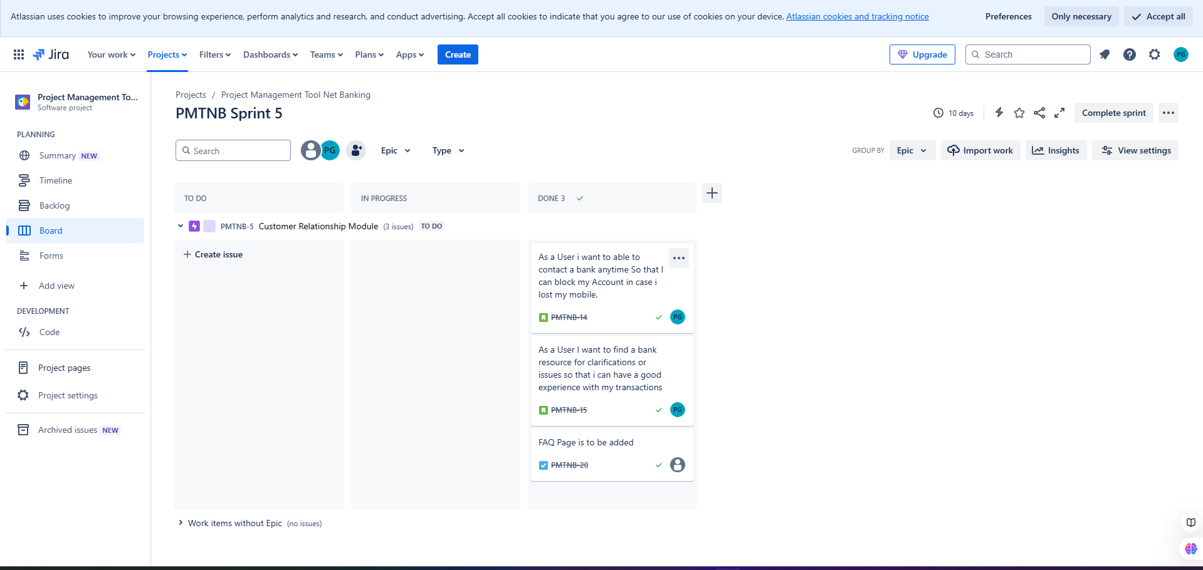

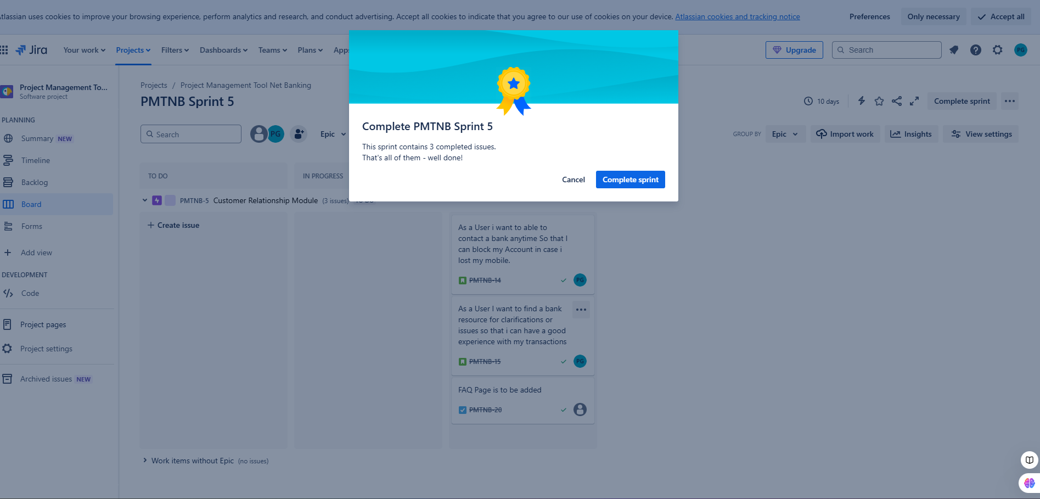

12.Time of this Project Net Banking Application
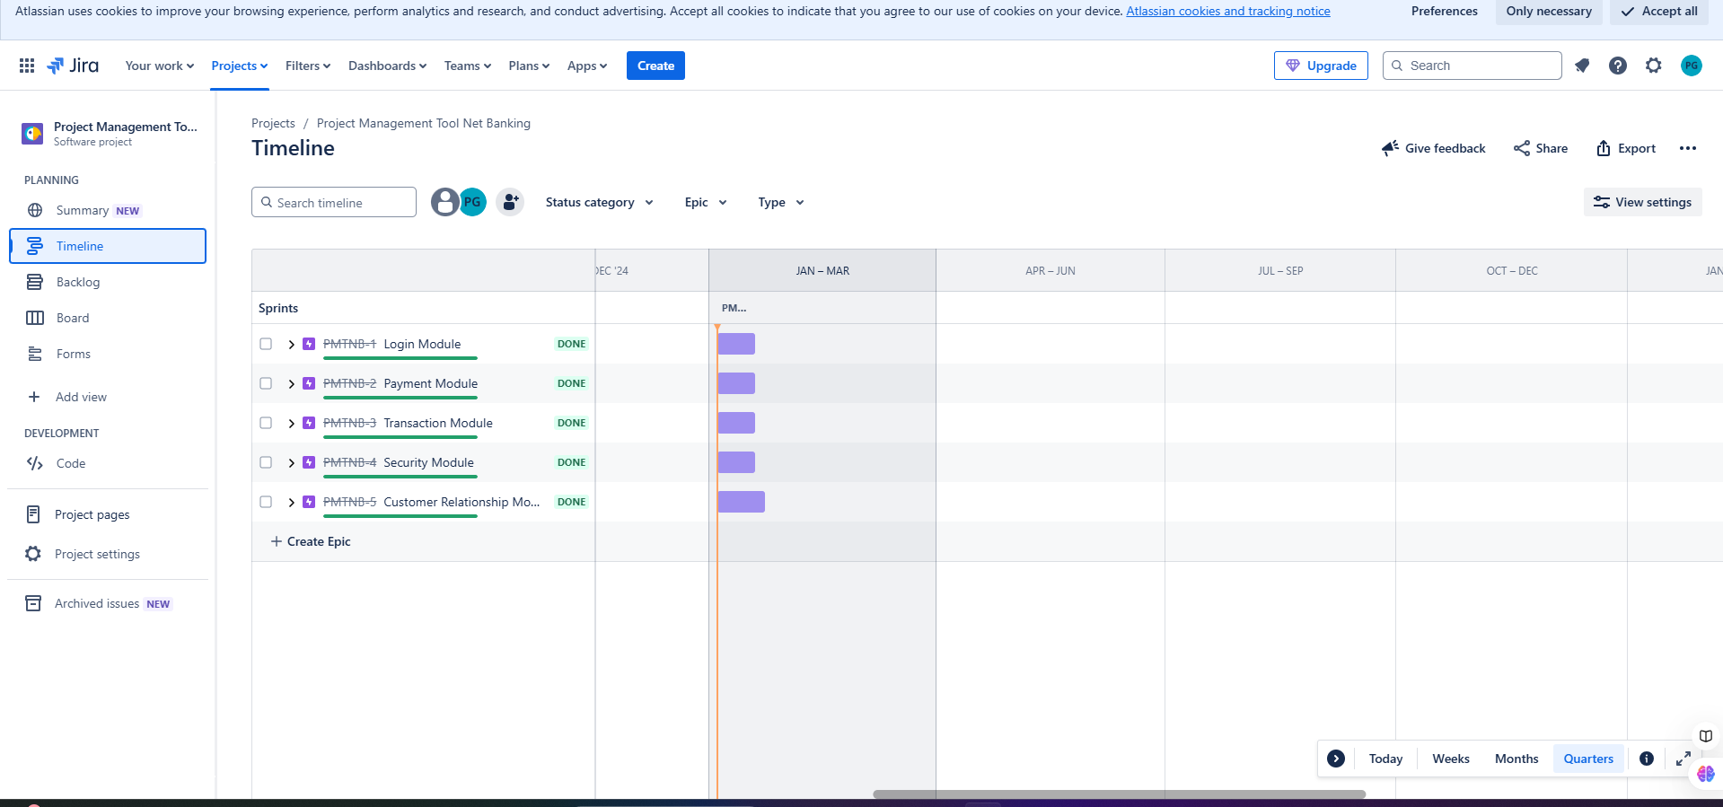
13.Summary of this Project
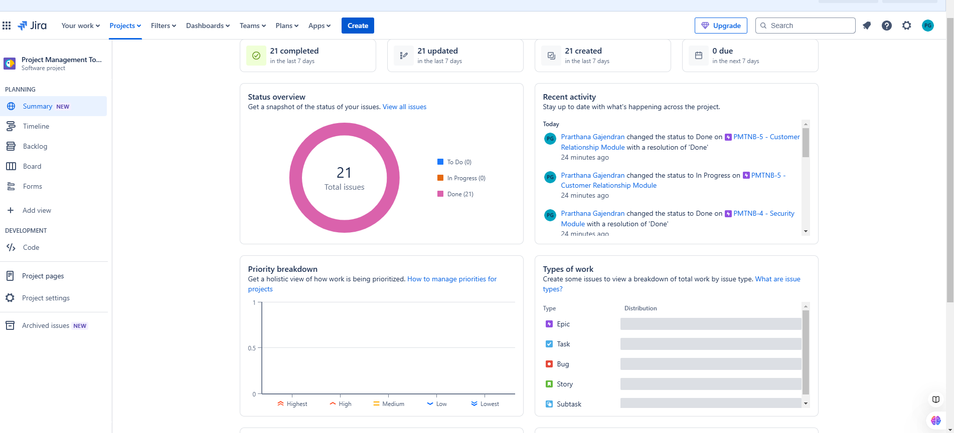

14.Sprint Retrospective:

What went well: Task completed on time.
What did not go well: Sprint 4 is little bit complex
Areas of improvement: Need to concentrate on Security Module.

15.Release Planning - Net Banking Application Version 1.0

8th January 2024

Login Module

  - Users can register in a Net Banking Application.
  - Users are able to Login the Application with valid User Name and Password.
  - User can able to Reset the Password
  - User can able to change Profile Information such as Mobile Number, Email etc.

Payment module

- Users can be able to Transfer Money from their Account to another account.
- User can able to select the Mode of Transactions

15th January 2024

Transaction module

- User can be able to see the transactions made in the Account
- User can able to download the transaction History
- User can able to pay Electricity bills, Phone bills

Security module

- User can able to get a message after every Transactions
- User can able to get the OTP for Authentication

Customer Relationship Module

- If User has any queries, they are able to contact the Bank Anytime.
- If User made a wrong transaction, they can contact the Bank to Stop the Transaction.

Roles involved in Scrum

Product Owner - Defines requirements and priorities

Business Analyst - Ensure clear documentation and requirements

Master - Facilitates the process and remove roadblock

Tech Architect Development team and Testing Team - Ensure to Develop and Testing the requirements

Operation Team - Handles deployment and Maintenance

